ECE 358 Networking Lab 1

# Question 1

The equation of PDF for the exponential random variable is the following.

$$f\left(t\right)= ℷ*e^{-ℷ*x}, where x ≥0$$

In CDF, the equation changes to the following.

$$f\left(t\right)=1-e^{-ℷ*x}, where x ≥0$$

$$e^{-ℷ*x}=1-f\left(x\right)$$

$$-ℷ*x=\ln\left(1-f\left(x\right)\right)$$

$$x= \frac{-1}{ℷ}ln⁡(1-f\left(x\right))$$

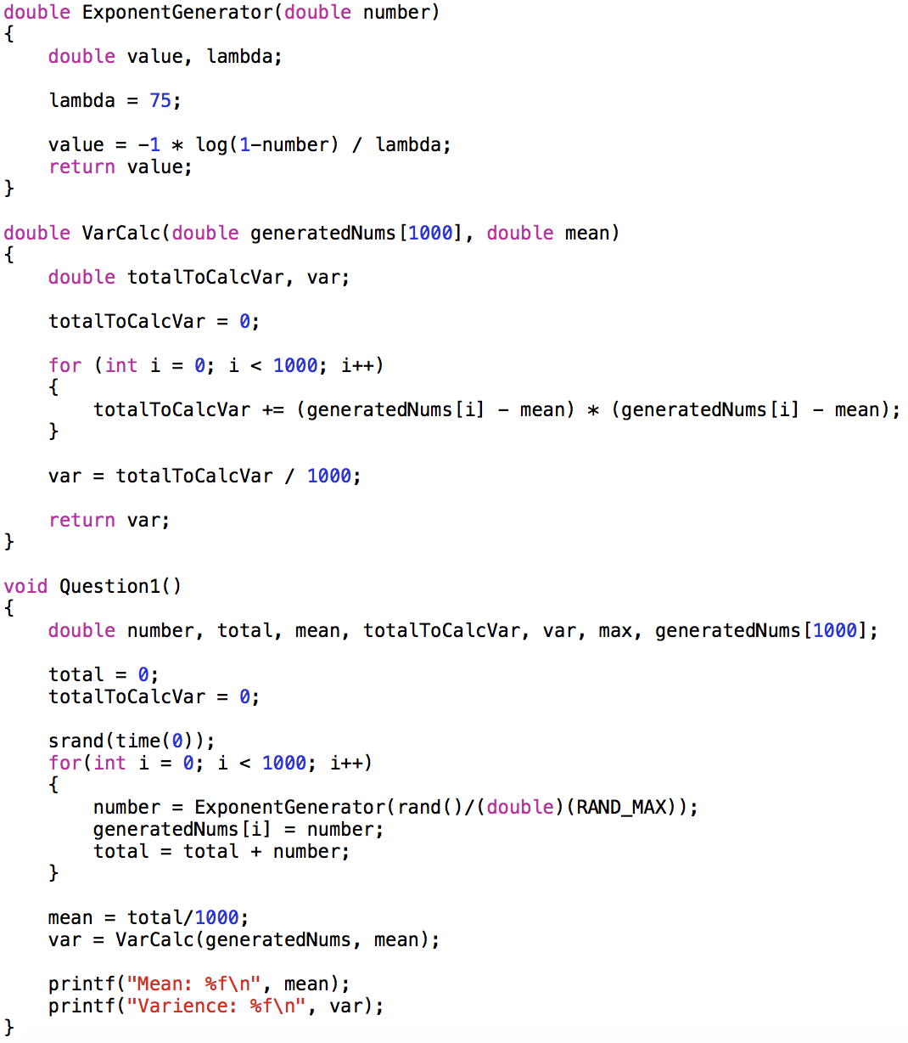

Figure 1. Exponential Generator



Figure 2. Mean and Variance of the Generator

I agree with the mean and variance. The expected mean of the exponential generator with $ℷ=75$ is $\frac{1}{ℷ}$, which is 0.01333. The percent error is 2.82%. The expected variance of the exponential generator with $ℷ=75$ is $\frac{1}{ℷ^{2}}$, which is $1.778*{10}^{-4}$. The percent error is 1.8123%.